A000-MEX-Chinesco (Nayarit)–Warrior Protecting Shaft Tomb-Terracotta—500 CE

[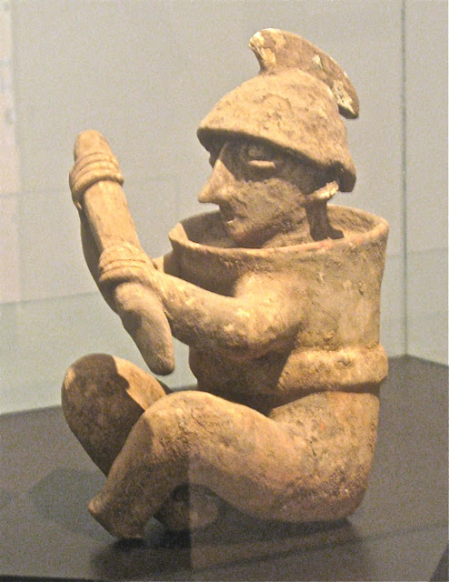](http://4.bp.blogspot.com/-Pm3JMDwLYeo/TwIHSbcNdEI/AAAAAAAAHpM/LO8yb7J7sB0/s1600/M-warrior.jpg)

**Warrior from Shaft Tomb near Etzatlán.** The warrior wears a crested helmet, possibly of wood or wicker. Around his body he wears wicker armor, shaped like a cylinder. In his hands he brandishes a club or a short spear. A large replica of this warrior stands guard over the entrance road to Etzatlán from Highway 4. The stance, weapon and armor of the warrior are similar to many found throughout the area of the Shaft Tombs. The number of warrior figures found, and the level to which they were armed and armored, indicates that this period in Western Mexico was not entirely peaceful.

**Case no.: 10**

**Accession Number:**

**Formal Label:** Chinesco (Nayarit)–Standing Male with Cap-Clay-Post Conquest-1540 CE

**Display Description:**

The Western Mexico shaft tomb tradition or shaft tomb culture refers to a set of interlocked cultural traits found in the western Mexican states of Jalisco, Nayarit, and, to a lesser extent, Colima to its south. Built beneath house platforms, these tombs served as family mausoleums and were periodically opened to inter the recently deceased. These two ceramic figures are fine representations of the Nayarit style known as Chinesco, notable for smooth burnished surfaces and painted ornament. These contrast with the heavy three-dimensional costumes and jewelry worn by figures in another local style, the Ixtlán del Río style.

**LC Classification:** F1219.3.P8

**Date or Time Horizon:** 500 CE

**Geographical Area:** West Mexico

**Map:**

Shaft tomb burials in West Mexico. After <https://upload.wikimedia.org/wikipedia/commons/thumb/d/d3/Ancient_Western_Mexico_Archaeological_Sites.svg/350px-Ancient_Western_Mexico_Archaeological_Sites.svg.png>

**GPS coordinates:** Huizilapa: 20° 51' 00" N, 103° 54' 00" W

**Cultural Affiliation:** Nayarit (Chinesco variant)

**Medium:** Terracotta

**Dimensions:**

**Weight:**

**Condition: original**

**Provenance:** John Thieren Estate, New York City, 1968.

**Discussion:**

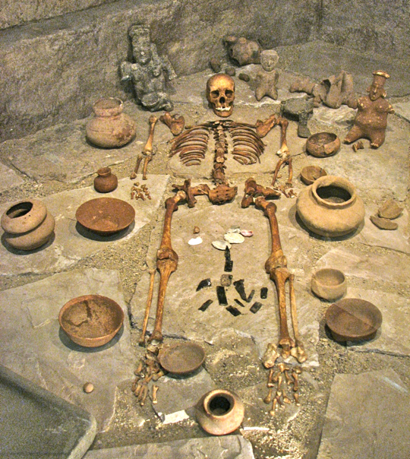

**Display of Shaft Tomb contents in Etzatlán's *Centro Cultural* museum*.*** After <http://1.bp.blogspot.com/-0LSKvsAxBrw/TwIFIwDrImI/AAAAAAAAHoE/px_xAWFC5GM/s1600/M-burial.jpg>. Skeletons with typical grave goods are among the displays in this little gem of a museum. Most of the artifacts in the museum were recovered from grave sites called *Tumbas de Tiro*, or [Shaft Tombs](http://en.wikipedia.org/wiki/Western_Mexico_shaft_tomb_tradition). One of most important of these tombs was found in 1955 on the former lands of the *ex-Hacienda de San Sebastian*. The people of these cultures inhabited the area in and around Etzatlán beginning more than 2000 years before the Spanish arrived in 1524. There were other cultures in the area during that time, but these are the ones that left the most accessible traces, including tombs, pyramids, and palaces.

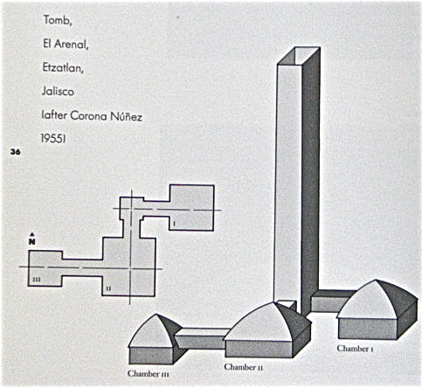

**Design of a Shaft Tomb found near Etzatlán.** After http://4.bp.blogspot.com/-MzjguqLaFx8/Ty6ninCSTFI/AAAAAAAAHu0/xcX22tHHBhE/s1600/Shaft+tomb+diagram1.jpg . As with most such tombs it was built with a vertical shaft (hence the name) cut down through volcanic tuff called *tepetate*. The depths of the shafts from the surface range from 4.6 meters (15 ft.) to more than 15 meters (50 ft.), and the number of chambers range from 1 to 5. The depth is particularly impressive given that the only digging tools available were sharpened sticks, rocks, and animal bones. In the tomb shown above, there are three large compartments connected by tunnels. After a burial, the shaft would be filled in up to the surface, and covered by a stone slab. At some shaft tombs, remnants of what may have been shrines were found covering the surface entrance. The Shaft Tomb found at *ex-Hacienda de San Sebastian* is about 7 kilometers (4.3 mi.) from Etzatlán andlies 16 meters (52 ft.) below the surface. The tomb chamber is 4.2 X 3.9 meters (14 ft. X 12.8 ft.) and is tall enough that a man could walk upright in it. (Design above from "Sculpture of Ancient West Mexico").

References:

Kan, Michael, Clement Meighan, H. B. Nicholson. 1989*. Sculpture of ancient west Mexico: Nayarit, Jalisco, Colima. A catalogue of the Proctor Stafford Collection at the Los Angeles County Museum of Art*. Albuquerque: Los Angeles County Museum of Art in association with University of New Mexico Press.

Appendix

AP 14

**References:**

Shaft tomb burials in West Mexico. After https://upload.wikimedia.org/wikipedia/commons/thumb/d/d3/Ancient_Western_Mexico_Archaeological_Sites.svg/350px-Ancient_Western_Mexico_Archaeological_Sites.svg.png

This Pre-Classic Nayarit (Chineswco) standing male figurine, 5 in. high, is wearing a cap and a stubby mustache, perhaps indicating his rôle as an interloper from Spain post Conquest. He has been used as a pouring device as he has a top loading opening and a spout coming from his right chest area. His face has been painted in a d in a cream slip, and a waistband also painted in a cream slip. The arms are well proportioned and his feet display shoes., Since this figure accompanied the deceased in a shaft tomb burial, it suggests that the importance of this figurine was to assist the interred in his journey to the after-life by being spiritually aware of his transfiguration. Figures similar to this are illustrated in Kan, Meighan and Nicholson 1989: pl. 17, p. 81, also see p. 27.

References:

Kan, Michael, Clement Meighan, H. B. Nicholson. 1989*. Sculpture of ancient west Mexico: Nayarit, Jalisco, Colima. A catalogue of the Proctor Stafford Collection at the Los Angeles County Museum of Art*. Albuquerque: Los Angeles County Museum of Art in association with University of New Mexico Press.